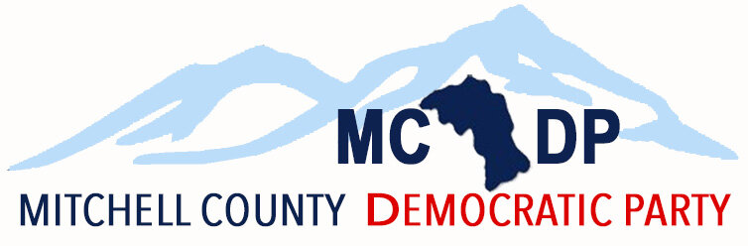

MINUTES
Mitchell County Democratic Party
Executive Committee Meeting
Blue Ridge Tacos
(6:00 - 7:35 p.m.)
February 12, 2024
Important MCDP Highlights:
- Eddie and Danna Gibson transported some of the coats/gloves/toboggans to The Beacon Center of Spruce Pine
- The party is in talks of participating in AMY Pride this year in June 2024.
- The party has ordered copies of the U.S. Constitution and Facts to distribute at our attendance of the AMY Pride and Rhododendron Festival- still awaiting meeting with M-Y Pride.
- The MCDP welcomed Dr. Sarah Taber, Democratic candidate for North Carolina Commissioner of Agriculture, to be the keynote speaker for the MCDP county-wide meeting on January 27, 2024.
- Chair Eddie and the Executive Team appointed, with the consent of the MCDP Executive Committee, Danna Gibson as the Mitchell County Democratic Party’s treasurer replacing Risa Larsen.
Important Democratic Events:
- February 17, 2024 – The MCDP Precinct Meetings will take place at the Mitchell County Board of Education conference room in Bakersville, NC (Actual Location:
- February 24, 2024 – State Executive Committee Meeting in Rocky Mount, NC
- March 16, 2024 – the MCDP County Convention will take place at the Mitchell County Board of
Education conference room in Bakersville, NC
- April 20, 2024 – the Eleventh District Convention
- June 1, 2024 – the NCDP State Convention
- August 19-22, 2024 – the Democratic National Convention in Chicago, IL
Event Proposals:
- Event proposal to invite Democratic Governor Nominee - Josh Stein to a Democratic Party Dinner.
- Event proposal for April - Democrats Hot Club
- Event proposal for September 7th - Unity Democrats Picnic
- Event proposal for August 17th - Ice Cream Social (at Riverside Park) Other information:
- Eddie (Chair) has nominated Virginia Downs to replace Carol Keating on the
Early Voting election cycle to the Mitchell County Board Of Elections - Grassy Creek Precinct
- Eddie (Chair) has also nominated Framton Gibson and Matt Hinson (election assistant) to replace Carol Keating. - Bakersville Precinct
- In January, Eddie (Chair) sent upcoming precinct meetings in the community calendar sections of the Mitchell News-Journal and WTOE/WKYK radio stations.
- The NCDP will be hosting resolution training Wednesdays the 14th and 21st which will generally go over the process the committee follows as well as best practices for writing resolutions and managing expectations.
- Eddie has received communications from several NCDP candidates who are running to be elected to the Democratic National Committee – five will be elected at the Winter SEC meeting in Rocky Mount, NC.
- The MCDP received its second check (for the third quarter of 2023) from Movement Labs in the amount of $220.00 which was deposited in the MCDP bank account on February 6, 2024.

